D.K.T.E. Society’s Textile and Engineering Institute, Ichalkaranji.

(An Autonomous Institute, Affiliated to Shivaji University, Kolhapur)

Department of Computer Science & Engineering

2018-19



**Project Synopsis On**

Multiplayer Bey-Battle Showdown Game

Using Augmented Reality

**Under The Guidance Of**

P.M. Gavali

**Submitted By:**

1. Indolikar Prathmesh Sudhir 15CMPN13
2. Yadav Akash Chaitanya 17CTRCMPN72
3. Digraje Abhinandan Shrenik 15CMPN04
4. Nilkanth Dhanraj Umesh 15CMPN37
5. Nagare Mrunal Sandip 15CMPN36

Prof. P. M. Gavali Dr. D. V. Kodavade

Project Guide Head of Department

**INTRODUCTION**

The project proposes the use of the concept of Augmented Reality. It is an interactive experience of a real-world environment whereby the objects that reside in the real-world are "augmented" by computer-generated perceptual information, sometimes across multiple sensory modalities, including [visual](https://en.wikipedia.org/wiki/Visual), [auditory](https://en.wikipedia.org/wiki/Hearing), [haptic](https://en.wikipedia.org/wiki/Haptic_perception), [somatosensory](https://en.wikipedia.org/wiki/Somatosensory_system), and [olfactory](https://en.wikipedia.org/wiki/Olfactory). The overlaid sensory information can be constructive (i.e. additive to the natural environment) or destructive (i.e. masking of the natural environment) and is seamlessly interwoven with the physical world such that it is perceived as an [immersive](https://en.wikipedia.org/wiki/Immersion_(virtual_reality)) aspect of the real environment. In this way, augmented reality alters one’s ongoing perception of a real world environment, whereas [virtual reality](https://en.wikipedia.org/wiki/Virtual_reality) completely replaces the user's real world environment with a simulated one. Augmented reality is related to two largely synonymous terms: [mixed reality](https://en.wikipedia.org/wiki/Mixed_reality) and [computer-mediated reality](https://en.wikipedia.org/wiki/Computer-mediated_reality).

Gaming ecosystem is constantly evolving. Creators and developers in the gaming industry are constantly developing new games, methods, technologies to capture the attention and imagination of gamers around the world. From Mario to Tetris to Halo and now Augmented Reality (AR) powered games like Pokémon Go; the bar just keeps going higher. AR games allow the gamer to fight aliens, catch whimsical creatures or save the kingdom- all in the real world.

AR superimposes computer-generated images on a user’s camera-screen-view of the real world. Pokémon Go proved to be the catalyst and a game changer for AR. Following the resounding success of Pokémon Go, game developers readjusted their games in order to add and adapt the new technological trend- AR. Augmented Reality helps in creating a combined view for the player, which is an amalgamation of the real world and virtual images created by the computer.

In these prospects, we will consider the benefits of the Augmented Reality. Augmented reality is a technology that works on computer “vision based recognition algorithms” which helps in adding intense sound, video, graphics and even smell. All the real world objects are added using the camera of the user’s device. Benefits derived from AR games are endless. Normal people (non-fanatics) are beginning to understand what it is like to play games using smartphones. Games have reached another level of sophistication, which is helping to engage the millennial generation. Another major application has been stimulation games. AR makes that cockpit or cabin feel real to the gamer and helps improve their real-life abilities in a safe environment. Similarly, it can help soldiers, drivers, and students to enhance their skills. So along with entertaining, AR games are proving to be a great learning tool as well.

Following tools will be used in the process of developing the proposed project stated under,

* Android studio (User Interface Building).
* Visual Studio (Interaction, backend coding).
* Database.
* Unity (Object Development).
* Vuforia (Object Development).
* Autodesk Fusion 360 (Object Development).
* Anaconda Navigator (Machine Learning).
* Windows 3D Paint

The proposed project will provide a thesis for various applications, ranging from various fields of Engineering like Civil Engineering, Mechanical Engineering and many more fields as follows,

1. **Entertainment.**

The proposed work will provide a source of entertainment as the users can engage themselves in a competitive play. Thus, giving the users an experience of virtual reality in real time environment.

1. **Concentration Improvement.**

Gaming reportedly increases concentration of the children. They learn to imbibe a competitive spirit in themselves. It also helps build a focused mind and a desire to win and compete with their colleagues.

1. **Exploring new dimensions in technology.**

Augmented reality is the trending topic and is proposed to be the beginning of a new era in the history of innovation. It will help in the simulation of realistic as well as unrealistic scenarios in various engineering and non-engineering fields.

**RELATED WORK**

1. Richard Sala & Santi Ristol have proposed a white paper on under the ATOS Syntific Community on Mobile Augmented Reality on July 2012, where they have stated the development of augmented reality in all the sectors of the industry and the position of in in the current state. According to their conclusion,” Atos sees augmented reality becoming a part of everyone’s reality in the next few years, transforming mobiles into advanced sensors and lives into connected networks. Augmented Reality Services will emerge from different sectors crossing over current niches to generate direct benefits to users, businesses and workers. Because users will need to download contents and information from the Internet, network performance and cost will be key. Indeed, the last market changes in flat-rate contracts may slow down AR adoption”.
2. Ms.Akil H.Sayyad & Prof. S.A.Shinde have proposed a white paper under International Research Journal of Engineering and Technology (IRJET) on Augmented Reality Based Mobile Tour Guide System on May 2016, where they have introduced a new tour guide system utilizing augmented reality in mobile environment by considering limitations of paper based and mobile based tour guide systems. This system consists of tourist point of interest and properly guide tourist.
3. Dr Martina Reiter have proposed a white paper under RE’FLEKT corporation on Enterprise Training with Augmented Reality on October 2017, where they have stated that, “AR will really improve training processes for industrial trainings. It is essential that companies show courage for this technological vision, and further support and drive AR content for their industrial trainings”.

**PROBLEM STATEMENT**

To develop a multiplayer interaction application using augmented reality which will take a marker-based recognition image using camera device and will provide virtual interaction between users.

**OBJECTIVE**

To implement a multi-user platform using augmented reality through an android application to provide a real time interaction experience.

**METHODOLOGY:**

The proposed work will have the following modules:

1. Login module.
2. User interaction module
3. Object module
4. Result module
5. Machine learning module
6. Database

**Architectural diagram :**

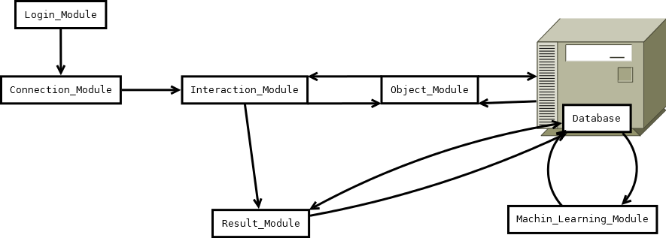

Figure (2): Dataflow Diagram

**Physical Components:**

1. Camera support
2. Video background renderer
3. Device database and image tracker.
4. Smartphone (Android 4.0 or more)
5. Android mobile application of the proposed project

**REFERENCES**

1. Cynthia Allum, Elyssa Goldberg, Matthew Weinberg, Rashmi Bhagwat, Siddharth Shanbhag,” State of Augmented reality”, page no.: 6.
2. Richard Sala & Santi Ristol,“ Mobile Augmented Reality” on July 2012, page no.: 10 (Augmented realty issues).
3. Ms.Akil H.Sayyad & Prof. S.A.Shinde,“ Augmented Reality Based Mobile Tour Guide System” on May 2016, section. 3, page no.:2 (Proposed System).
4. Dr Martina Reiter,” Enterprise Training with Augmented Reality” on October 2017.